Appendix I: Flowcharts of Management Pathway

Chart 1: Atypical Ductal Hyperplasia (ADH)
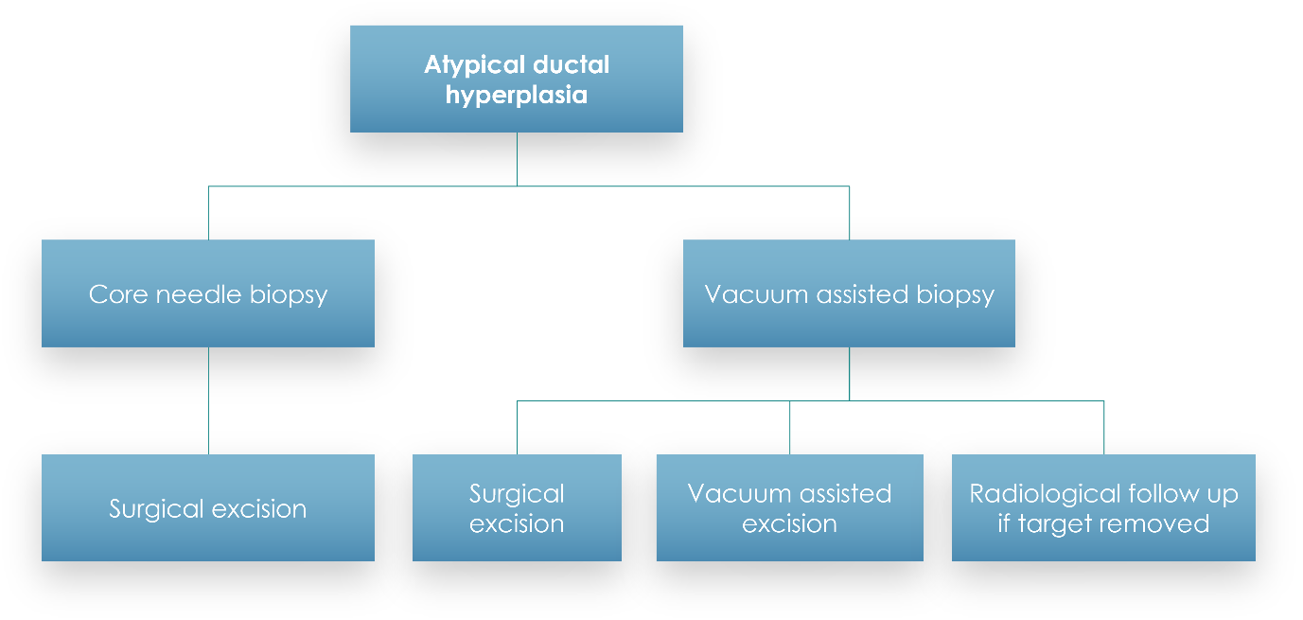

Chart 2: Flat Epithelial Atypia (FEA)
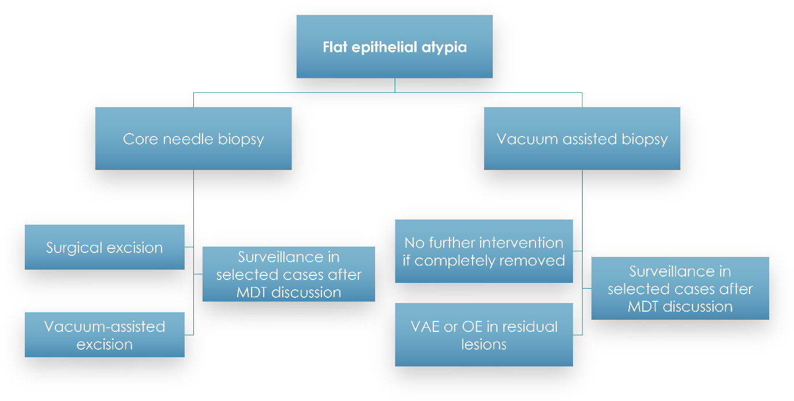

Chart 3: Classical Lobular Neoplasia (LN)
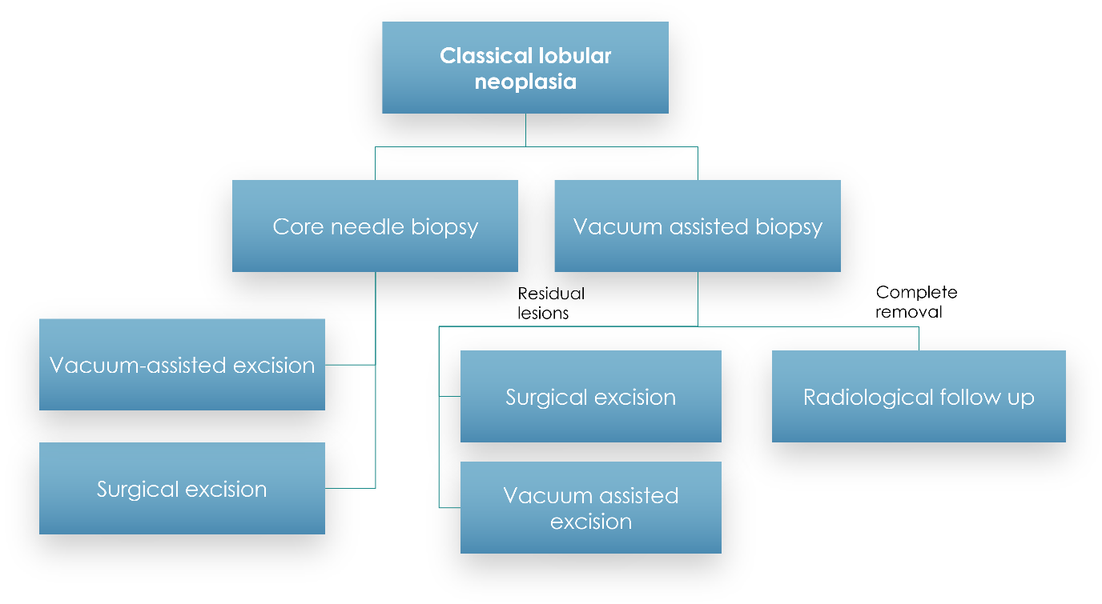

Chart 4: Papillary lesions without atypia (PL)
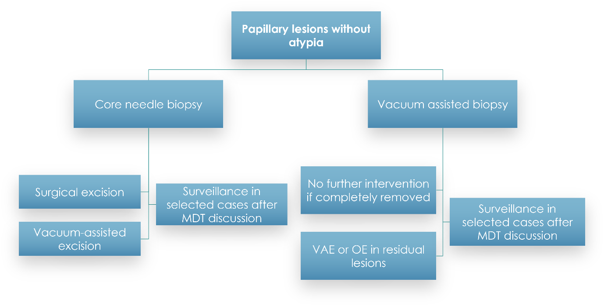

Chart 5: Benign and borderline phyllodes tumor (PT)
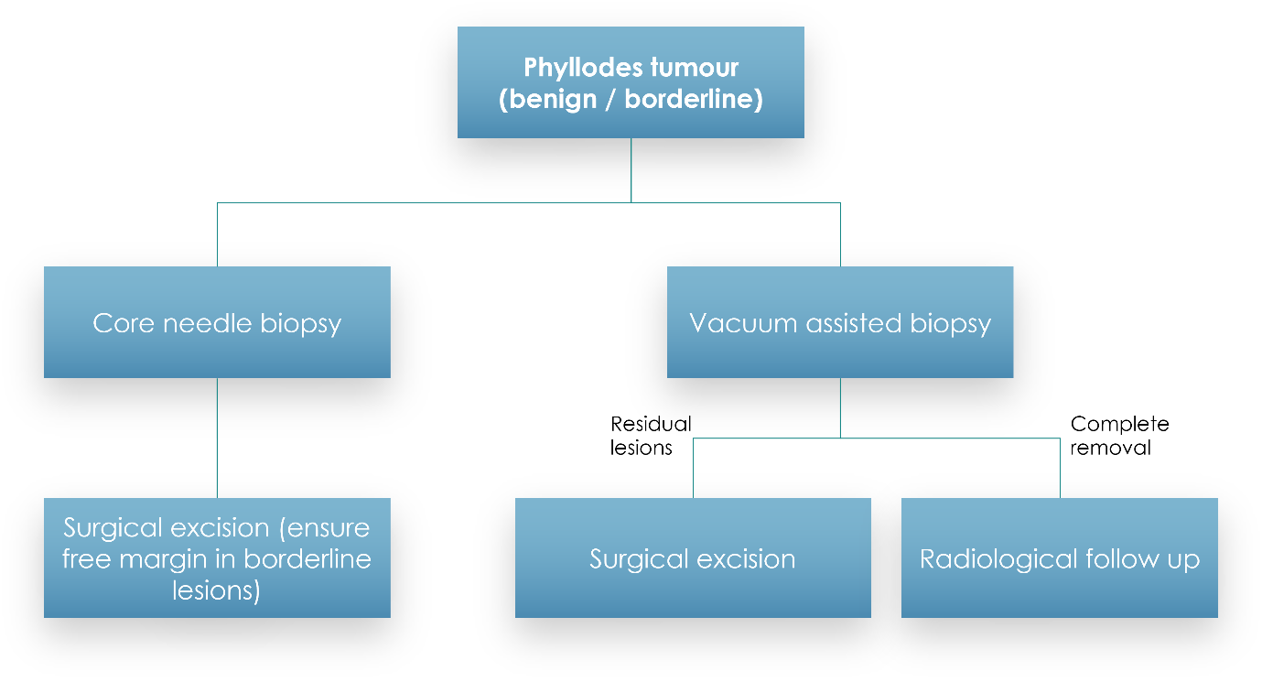

Chart 6: Radial scar (RS)
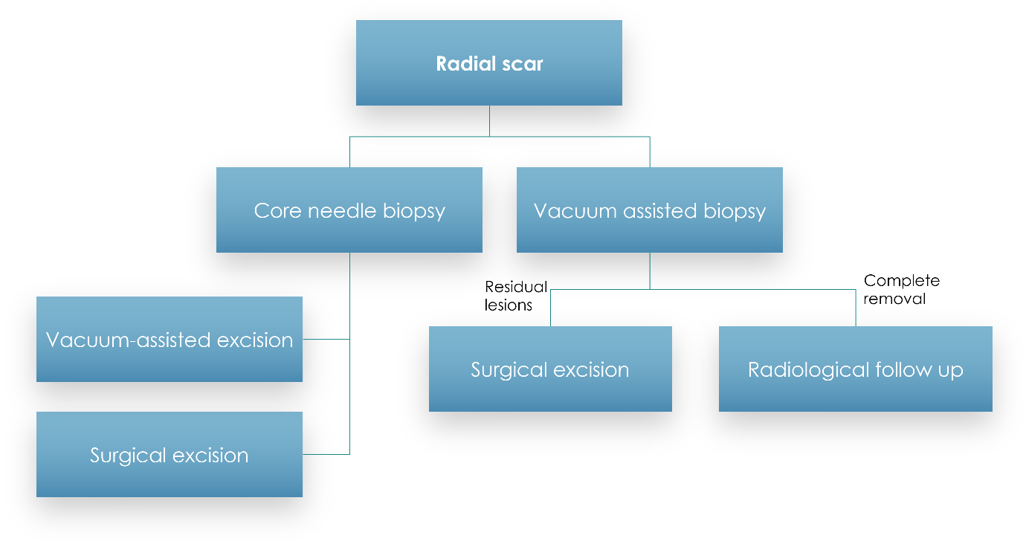

Remarks:
For core needle biopsy, 14G achieve or Magnum needle were used. For vacuum-assisted biopsy, 10G Encor needle was used. At least 3 samples would be obtained for each lesion.
For vacuum-assisted excision, we aimed to remove the index lesion or residual lesion. No free margin would be required except in borderline phyllodes cases.
In our centre, 10G Encor needle will be used with 18 samples taken or entire removal of the index lesion. Equivalent samples could be taken for 7G / 9G needle according to own institution practice.

