Developing a Business Case for recruitment of CO trainees

Introduction
The aim of this document is to provide background information and data that can be incorporated into your local business case when applying for an increase in Clinical Oncology (CO) training places. Many hospitals/centres have a template that should be completed but we have aimed to include the most common sections. However, the document is designed for you to choose as much or as little detail as required to write a business case for your hospital or centre. Where possible, we recommend that you write this alongside a business or finance manager who should be able to provide data on local costing and who will have experience of writing business cases. We also recommend that you include RCR CO Workforce Census data that apply to your hospital or region, and we have included the contact details below for how to obtain these from the College.

How to use this document
Please feel free to cut and paste from this document and use whichever parts are useful. Some sections have grey text in italics which are suggestions of which pieces of locally specific data to include, which you will need to find and input. The sections are ordered in this document in a way that we think make for a well-structured business case. We would welcome feedback when you have used it so we can continue to improve this resource. This document was constructed for CO, but large parts can be applied to Medical Oncology (MO) and other kinds of Oncologist.

Content
- Background
- National situation
- Local situation
- Workforce
- National Situation
- Local situation
- Capacity and demand evaluation
- Current establishment consultants
- Current establishment trainees
- Current establishment in comparison to other centres
- Benefits of trainee recruitment
- Potential consequences of not recruiting trainees
- Option appraisal
- Do nothing.
- Appoint locums.
- Recruitment of trainees to grow local workforce
- Mitigation
- Financial position
Background
This section can be adapted according to your local situation, but the aim is to explain the need for recruitment of trainees to build the workforce of the future.
National situation
Clinical Oncology (CO) continues to see rising demand in activity year on year. An expanding and aging population means cancer incidence is rising 3% per annum. More treatment options mean the prevalence of cancer is rising much more than the incidence. Patients live longer, need more clinic visits and treatments, and the management of complex symptoms and side effects is increasing. This is compounded by a national shortage of consultant clinical oncologists, which has resulted in increased waiting times, pressure on the existing workforce and a dependency on high-cost agency locums.

Whilst cancer incidence is only going to increase, with one in two of us predicted to have cancer in our lifetimes, growth of the CO workforce has remained minimal at 3% per annum since 2016.

Local situation
Insert here data on the local demographics with regards to cancer incidence and prediction for the future demand. This could include:

Demographics of population:
- Age (proportion over 55)
- Deprivation
- Ethnicity

Increasing complexity of treatment:
- Examples of new treatments that have been established without any increase in workforce e.g. SABR
- Examples of new SACT treatments and indications
- Genomics and the increased indications for SACT

Workforce
National situation
See background section for information.

Evidence from RCR Workforce Census
In 2021 the UK continued to have a 17% shortfall in CO, which translates to 189 clinical oncologists. Without investment in the CO workforce, the shortfall is estimated to increase to 26% (381) by 2026. Nationally, 46% of breast clinical oncologists and 32% of lung clinical oncologists are due to retire in the next 10 years and the proportion of consultants over 55 or working less than full time (LTFT) has grown to 4 in 5. Importantly, heads of department reported that:

- 67% concerned that workforce shortage will affect quality of patient care.
- 88% concerned about delayed treatment.
- 92% concerned about workforce shortages in site specialities.
- 100% concerned about workforce morale, stress, burnout, and pensions.

Local situation
In this section include detail about your local workforce situation.

Capacity and demand
In this section you can include local data on demand, with where possible an estimate of projection of future demand. Data could be split by:

- RT - these data can be obtained from Radiotherapy Dataset
- Systemic Anti-Cancer Therapy (SACT) – available from the SACT dataset
- New and Follow -up numbers.
- Cancer waiting times data.
- Increasing complexity of treatment
- CO job planning guidance, especially related to site specialisation and number of new patients.

The demand can be equated into current Full Time Equivalent (FTE) time and projected time needed to meet current demand and future projected demand.

Current Trainee Establishment
In this section you should/could include:

- Current CO trainee numbers
- Trainee to consultant ratio

Current Consultant, SAS, and Trust grade post Establishment

In this section you should/could include:

- Current CO establishment and benchmark this against the regional and national pictures – please contact RCR_WorkforceCensus@rcr.ac.uk to discuss these data for your centre. Regional data are available in the RCR Clinical oncology census report 2021
- Number of consultants over 55 or considering retiring, with timeframe if available
- Any vacant consultant posts >12 months
- Any difficult to recruit to tumour sites.

Benefits of trainee recruitment
Points to consider including in this section:

- The RCR has published a document that demonstrates the cost-effectiveness of investing in training:
  - This has estimated that if similar trends in workforce recruitment and retention continue, we will need 700 more consultants by 2030
  - Even if overseas recruitment was increased by 50% and there were benefits from developments in AI then that would still leave at least an 18% gap in recruitment whereas investing in trainee recruitment will fulfil 95% of the required workforce. Appendix A includes a diagram summarising the risks of the overseas/technology model.
- Trainees have direct benefits for the hospital/centre:
  - Come into speciality already highly trained at ST3.
  - In house management of medical problems
  - On-call
  - Training to service ratio (HEE recommended) 44% : 56% (see Appendix B)
  - Specific requirement for acute oncology training to support acute medicine.
  - Specific training to lead an acute oncology service of the future.
  - Service contribution, seeing new patients and follow-up patients under supervision, managing patients receiving radiotherapy and SACT. The recommended ratio of service to training will depend on experience and year of training (see Appendix B).

- Wellbeing – trainees improve the working environment for everyone and will help recruitment and retention.

- HEE evidence suggests that trainees are highly likely to settle long term in the area where they did their speciality training.

- Capacity and demand – trainees will help to address the capacity/demand situation due to the ratio of training/service model (see Appendix B)

- Increasing the numbers of trainees will ensure a robust on-call rota reducing the cost of locums.

- Include here data on recruitment and retention of locally trained trainees.

- You might include data from the national training survey (NTS) on trainee experience locally in support of the high standard of training you provide.

Potential consequences of not recruiting trainees
Points to consider including in this section:

- RCR CO Workforce Census data confirm that the level of unfilled posts is consistent across the UK (see Appendix C for diagram for England and 4 nations). It is therefore unlikely that vacant posts will be filled by trainees from other regions.
- There are few consultant locums to fill gaps and locums can be an expensive and, in some cases, an unstable solution.
- There is a risk that consultant posts will remain unfilled or will not be recruited to. The diagram below outlines the consequences of lack of workforce capacity and could be adapted to the local situation.
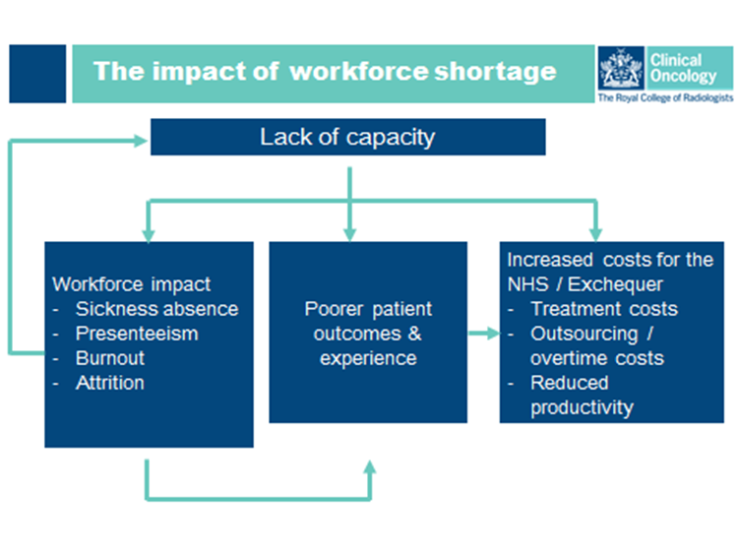

- You could consider reflecting on your NTS survey and potential impact on the experience of current trainees which could potentially impact on trainee recruitment in the future.

Option appraisal
Option 1 - do nothing.

Points to consider include:

- Unable to meet demand of cancer services due to unfilled consultant posts resulting in:
  - Patients travelling to other centres for treatment.
  - Inability to provide new radiotherapy techniques.
  - Inability to provide new drug treatments e.g. new NICE technology appraisals.
  - Inability to treat according to new national guidance e.g. NICE/RCR.
  - Increased waiting times for appointments/treatment.
- Lack of capacity to deliver cancer services locally leading to poor patient experience and outcomes, risk of reputational damage and safety concerns – for example, missing national targets for waiting and/or treatment times.
- Reduced ability to deliver on key activities such as research and development.
- Increased stress and burnout in current consultant workforce resulting in further gaps in service and capacity.
- Increased use of locums with additional financial burden
- Poor trainee experience reflected in NTS data resulting in difficulty in recruiting to current training posts.

Option 2 - Appoint locums.

Points to consider include:

- Lack of appointable or appropriately trained locums e.g no or limited SACT or AO experience
- Additional financial pressure
- Can be short term or unstable situation adding further to the pressure on current substantive consultant workforce.
- Limitations on the length of locum consultant posts e.g your hospital/centre might only allow a locum appointment for X months/years.

Option 3 - increase trainee numbers

Points to consider include:

- Long term sustainable and cost effective solution as evidenced by RCR published document
- Percentage of trainees progressing to substantive consultant posts within your centre/hospital in the last x years.
- Ability to recruit to current training posts, give data on percentage of posts filled in last x years.

Mitigations
In this section consider including actions that have been taken already to mitigate the loss of consultant time/workforce. Examples could include:

- Use of skill mix
  - ACPs
  - CNS
  - Consultant radiographers
  - Consultant pharmacists
  - Dosimetrists/physicists
- Employment of SAS doctors
- Change in follow-up or review process/protocols.
- Use of remote working
- Use of AI – e.g. auto-contouring

Financial position
Speak to your finance director to help complete this section.

Appendix A
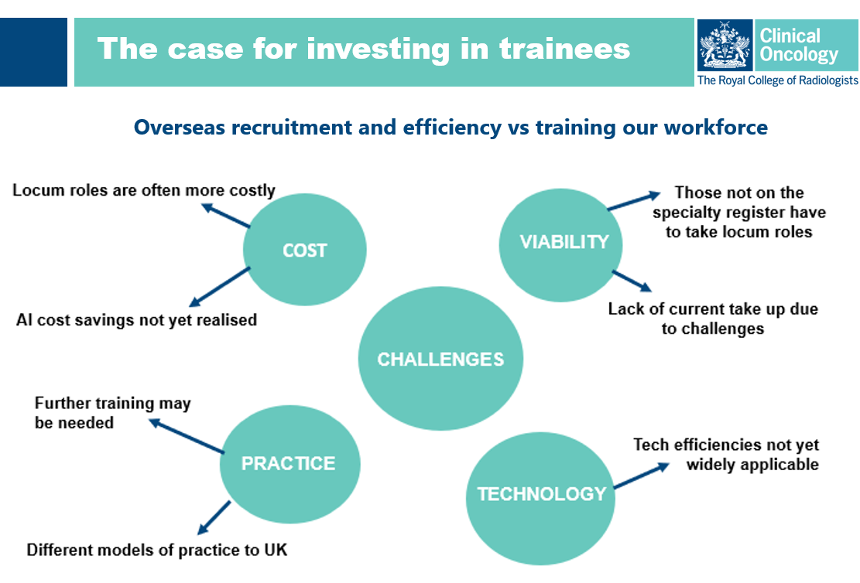

Source: RCR presentation delivered at HEE Workforce Day October 2022

Appendix B

The training service split is as follows:

Proposed range to spend on educational activities is approximately 55% for ST1 - ST2 and 45% for ST3 – ST7.

Source: based on internal conversations between RCR and HEE.

Appendix C

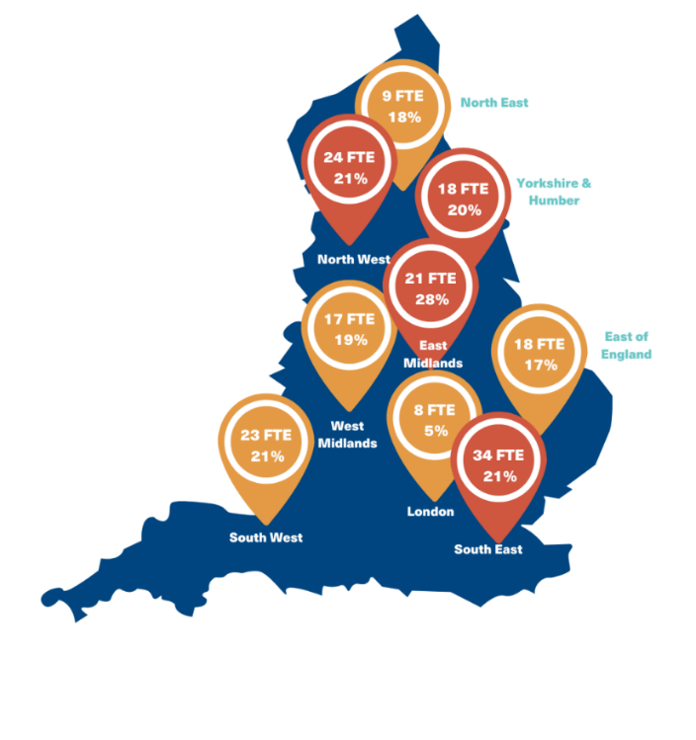
Current workforce shortage England
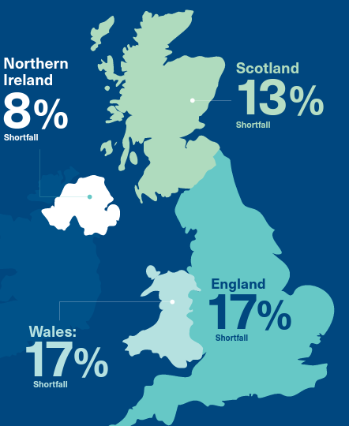

Current workforce shortage Scotland
Overall 13%

Current workforce shortage Wales
Overall 17%

Current workforce shortage NI
Overall 8%

RCR workforce census 2021

